Module 3: Module 3: Benefits, Provisions, and Ownership Rights

Lesson 3: Life Insurance Policy Ownership Rights

Learning Objectives


After studying this lesson, you will be able to:
- Identify the property rights that a policyowner has in an individual life insurance policy.
- Distinguish between primary and contingent beneficiaries and identify the person in a given situation who is entitled to receive policy proceeds following the insured’s death.
- Distinguish between revocable and irrevocable beneficiaries and describe restrictions imposed on beneficiary changes.
- Recognize the premium payment modes that insurers typically offer on individual life insurance policies.
- Describe the policy dividend options that most commonly are included in participating life insurance policies.
- Describe the settlement options that typically are included in life insurance policies.
- Identify the methods by which ownership of a life insurance policy can be transferred.

Policy Ownership Rights

Learning Objective
Identify the property rights that a policyowner has in an individual life insurance policy.
Distinguish between primary and contingent beneficiaries and identify the person in a given situation who is entitled to receive policy proceeds following the insured’s death.
Open Transcript
Could you answer Ethan's questions?

Things we own—cars, jewelry, land, securities—are considered our property, and we have certain rights in that property. A life insurance policy is a type of property.
We can use and enjoy our own property, and when we don’t want it anymore, we can sell it or give it away.

There are two primary categories of property: real property and personal property. Which type of property is a life insurance policy?
^{Real property}
^{Personal property}

Types of Property
Real property is land and whatever’s attached to the land. Personal property is all property other than real property. A life insurance policy is personal property.
Personal property can be classified as tangible or intangible. If the property has a physical form, like a car or clothing, it’s tangible. Intangible property represents legal rights.
A life insurance policy is intangible personal property because it provides the owner with legal rights that have value and that courts can enforce.

Ownership of property is the total of all legal rights in the property. Most of the ownership rights in a life insurance policy are set out in the policy. Typically, the owner of an insurance policy—rather than the insured or the beneficiary—holds the ownership rights in an insurance policy.

What ownership rights does a life insurance policyowner have? (Choose all that apply)
Name the beneficiary of the policy
Change the beneficiary of the policy
Transfer ownership of the policy to someone else
Determine the insured’s risk classification
Submit

Beneficiary Designations

The beneficiary designation in a life insurance policy identifies who will receive the policy’s proceeds at the death of the insured. The beneficiary of a life insurance policy can be
- A named individual
- An estate
- A trust
- A corporation
- A charitable organization
Any entity recognized by the laws of the jurisdiction in which the policy is issued may be a beneficiary.
Life insurance policies sometimes include a class beneficiary designation. What is a “class designation”? Do you think the picture below is a class designation?

No! A class designation is when the policyowner names a group of individuals as beneficiary. Example: "my children."


Primary and Contingent Beneficiaries
Beneficiaries are either primary beneficiaries or contingent beneficiaries.
Unless the primary beneficiary dies before the insured, the policy proceeds will be paid to the primary beneficiary.
Contingent beneficiaries receive policy proceeds only if all primary beneficiaries predecease the insured.
Examples
Morton Navinsky was the policyowner-insured of a life insurance policy that named his wife, Sonia, as primary beneficiary and his sons, Boris and Dimitri, as equal contingent beneficiaries.
Q: If Sonia and both sons are alive when Morton dies, who gets the policy proceeds?
A: The policy proceeds are payable to the primary beneficiary, Sonia.
Q: If Sonia and Boris predecease Morton, and Dimitri is living when Morton dies, who gets the policy proceeds?
A: Dimitri is entitled to receive the policy proceeds as the sole surviving contingent beneficiary.
But what if Morton had named his sons, Boris and Dimitri, as equal primary beneficiaries and his wife, Sonia, as contingent beneficiary?
Q: If Boris predeceases Morton, and both Dimitri and Sonia are living when Morton dies, who gets the policy proceeds?
A: Dimitri is entitled to receive the policy proceeds as the sole surviving primary beneficiary.
A policyowner can name more than one primary or contingent beneficiary and indicate how the proceeds are to be divided.

For example, if there are three primary beneficiaries, the policyowner may specify that one primary beneficiary gets one-half of the policy’s proceeds, and the other two primary beneficiaries each get one-fourth of the policy’s proceeds.

If the policyowner doesn’t say how to divide the proceeds, the insurer will divide the proceeds equally among the eligible beneficiaries.
Open Transcript
Review the flowchart to see how insurance companies identify who should get the policy benefit.
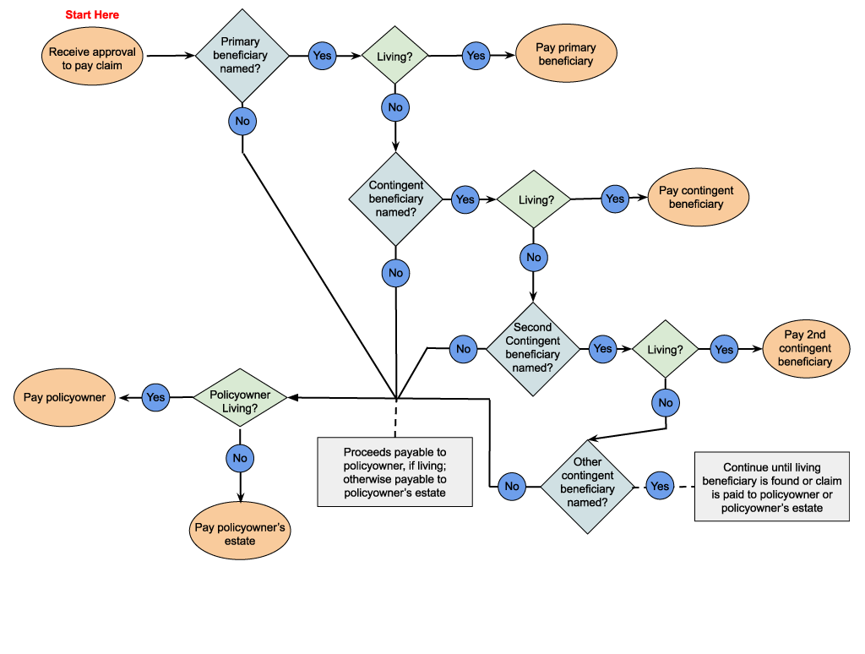
Image Description

Ira Shulman had a $50,000 policy on his own life. His primary beneficiary was his wife, Myna, and his contingent beneficiaries were his sons, Abraham and Daniel, equally. Ira was survived by his wife and both sons. Who gets the policy benefit?
^{Myna}
^{Abraham}
^{Daniel}
^{Abraham and Daniel}
Robin McNamara had a $200,000 life insurance policy on his own life. His primary beneficiary was his wife, Elise, and his contingent beneficiaries were his children, Emma and William, equally. Both Elise and William died several years before Robin died. Who gets the policy benefit?
^{Robin's estate}
^{Elise’s estate}
^{William’s estate}
^{Emma}
Leigh Komesar had a $500,000 life insurance policy on her own life. Her primary beneficiaries were her daughters, Sonja and Alyssa, equally, and her contingent beneficiary was her husband, Bradley. Sonja died several years before Leigh, who was survived by Alyssa and Bradley. Who gets the policy benefit?
^{Sonja’s estate}
^{Alyssa}
^{Bradley}
Nina Reno had a $1 million life insurance policy on her own life. Her primary beneficiary was her brother, Jim, and her contingent beneficiary was her sister, Janet. Both Jim and Janet died several years before Nina. Who gets the policy benefit?
^{Jim’s estate}
^{Janet’s estate}
^{Nina’s estate}

Revocable and Irrevocable Beneficiaries

Learning Objective
Distinguish between revocable and irrevocable beneficiaries and describe restrictions imposed on beneficiary changes.

Revocable Beneficiary

Life insurance policies usually give the policyowner an unlimited right to change the beneficiary designation at any time during the insured’s lifetime. This right is known as the right of revocation.
Most beneficiaries have no right to the policy proceeds while the insured is alive and are known as revocable beneficiaries.
However, in some cases, the right to change the beneficiary may be limited…

Irrevocable Beneficiary

Sometimes a policyowner makes an irrevocable beneficiary designation. In that case, the policyowner usually can’t change the beneficiary or exercise other ownership rights, such as take out a policy loan or surrender the policy, without the beneficiary’s consent.
A revocable beneficiary has a ‘mere expectancy’ of receiving policy proceeds, but an irrevocable beneficiary has a property right—a vested interest—in the policy even while the insured is alive.
If an irrevocable beneficiary dies before the insured, then the beneficiary’s vested interest ends and the policyowner can name a new beneficiary.

Community-Property States
In some states, laws limit a policyowner’s right to change a beneficiary designation. One example is community-property state laws.
In a community-property state where spouses are entitled to an equal share of each other’s income or property acquired during the marriage, a life insurance policy acquired during the marriage is community property.


Ricardo Sanchez bought a policy insuring his own life. He named his wife Selena as irrevocable primary beneficiary and his son Javier as contingent beneficiary.

When Ricardo died, Selena had died and Javier was living. In this case, the insurer will pay the policy proceeds to
^{Javier}
^{Selena’s estate}

Premiums and Policy Dividends

Learning Objective
Recognize the premium payment modes that insurers typically offer on individual life insurance policies.
Describe the policy dividend options that most commonly are included in participating life insurance policies.

Premium Payment Modes

A policy’s premium payment mode is how often the policyowner pays renewal premiums.
Insurers typically offer these modes:
- Annually
- Semiannually
- Quarterly
- Monthly
The applicant selects the mode when she applies for the policy and usually can change it after the policy is in effect.
To keep administrative costs down, insurers typically require scheduled renewal premiums to be at least a minimum amount. For example, Able Life might require a minimum payment of at least $50 for a policyowner to pay premiums monthly.
Insurers also usually charge more than a prorated portion of the annual premium amount for more frequent premium payment modes, such as monthly.
Example: If an annual premium payment is $2,400, the monthly amount would be more than 1/12th of that ($200) to cover the additional administrative expense.

Participating and Nonparticipating Policies

A life insurance policy may be participating or nonparticipating.
The owner of a participating policy can share in the insurance company’s profitable operations by receiving a portion of its divisible surplus.
Divisible surplus = the amount of an insurer’s earnings available for distribution to owners of participating policies
The owner of a nonparticipating policy has no right to share in the insurer’s divisible surplus.
What exactly is an insurer’s surplus?
Surplus is an accounting term. To understand it, you need to understand the basic accounting equation:
Assets = Liabilities + Owners’ equity
- Assets are all things of value owned by a company. Examples: cash and investments.
- Liabilities are a company’s debts and future obligations. For insurers, the most important liabilities are policy reserves, which represent estimated amounts needed to pay policy benefits as they come due.
- Owners’ equity is the difference between assets and liabilities, and it represents the owners’ financial interest in the company. For stock insurers, owners’ equity is called capital and surplus. Capital is the owners’ investment in the company and surplus is excess of assets over liabilities and capital. For mutual insurers, who don’t issue stock, owners’ equity consists only of its surplus.

Policy Dividend
Owners of participating policies can share only the portion of the surplus designated as divisible surplus.
An insurer shares its divisible surplus through policy dividends, which are essentially premium refunds, not taxable income like stock dividends are.
Policy dividends aren’t guaranteed, but most insurers periodically pay dividends on their participating life insurance policies that are expected to remain in force over a long term.
Participating policies contain a policy provision that gives the policyowner several choices or dividend options for how to use or receive a policy dividend.

Policy Dividend Options
Mostly, the names of the policy dividend options describe each option well.
- Cash dividend option--Insurer sends a check to the policyowner.
- Premium reduction dividend option--Insurer applies a policy dividend toward premium payments
- Policy loan repayment dividend option--Insurer applies a policy dividend toward the repayment of outstanding policy loan
- Accumulation at interest dividend option--Insurer keeps a policy dividend on deposit earning interest
- Paid-up additional insurance dividend option--Policy dividend used to purchase additional coverage of the same type as the basic policy
- Additional term insurance dividend option--Policy dividend used as a net single premium to purchase one-year term insurance
Three of these policy dividend options deserve a little more attention.

Accumulation at interest dividend option Steven Maxwell owns a participating life insurance policy on his own life. The policy dividends are left on deposit with the insurer to accumulate at interest. Steven can withdraw part or all of these dividends and interest at any time.
If Steven surrenders the policy, the insurer will pay him both the accumulated value of the policy dividends and the policy’s cash surrender value. When Steven dies, the dividends on deposit are payable to his named beneficiary, who would still receive the dividends even if Steven was not the policyowner.

Paid-up additional insurance dividend option When Enrique Sosa was 45 years old, he purchased a $100,000 participating whole life insurance policy. The total death benefit increases each time the insurer declares a policy dividend, and currently, the death benefit for Enrique’s policy is $113,452. The $13,452 represents additional paid-up insurance since the inception of the policy.

Additional term insurance dividend option Dividends earned by Deandra Mooney’s participating policy are used to purchase one-year term insurance on her life. The amount of term insurance cannot exceed the policy’s cash value.

If the policyowner has not chosen a policy dividend option, most insurers have a default option in their policies known as an automatic dividend option.

What do you think is the most common automatic dividend option?
^{Cash option}
^{Premium reduction option}
^{Policy loan repayment option}
Accumulation at interest option
Paid-up additional insurance option
Additional term insurance option

Settlement Options and Ownership Transfer

Learning Objective
Describe the settlement options that typically are included in life insurance policies.
Identify the methods by which ownership of a life insurance policy can be transferred.
(Click or touch the arrows to the right.)

"Hello, my name is Gloria. How may I help you?"
Receiving policy proceeds:
- Lump-sum or other settlement options

Settlement Options

The settlement options provision in a policy grants a policyowner or beneficiary several choices or settlement options for receiving life insurance policy proceeds.
The policyowner may select a settlement option for the beneficiary and can make that choice revocable or irrevocable. Unless the policyowner chose an irrevocable option, the beneficiary may select a settlement option when the policy proceeds are payable.

Payees
The person or party who receives the policy proceeds under a settlement option is the payee.
The party who elects an optional mode of settlement—either the policyowner or the beneficiary—also can designate a contingent payee, or successor payee, who will receive any proceeds still payable when the payee dies.

Settlement Options
Settlement options are similar to annuity options.
Interest option
The insurer invests proceeds and pays the interest to the payee, typically annually.
Fixed-period option
The insurer pays proceeds in equal installments for a specified period.
Fixed-amount option
The insurer pays proceeds in equal installments of a specified amount until policy proceeds and interest are exhausted.
Life income option
The insurer pays proceeds in periodic installments over at least the payee’s lifetime.
That life income option sounds interesting. Please tell me more about it?

Start

Life Annuities
Straight life annuity
Periodic benefit payments continue throughout the annuitant’s lifetime and cease at his death.
Life income annuity with period certain
Guarantees that annuity benefits will be paid throughout the annuitant’s life and for at least a certain period, even if the annuitant dies before the end of that period.
Life income annuity with refund
Provides annuity benefits throughout the annuitant’s lifetime and guarantees that at least the purchase price of the annuity will be paid in benefits.
Joint and survivor annuity
Provides a series of payments to two or more individuals and those payments continue until both or all of the individuals die.
I really need some time to think about this.

Start

See if you can help Ms. Yanar by choosing the correct type of annuity for each example.

Ms. Yanar wants to receive annuity income for life. She also wants to be sure that the annuity makes payments for at least 10 years. If she dies before the end of 10 years, her beneficiary will receive the remaining payments.
^{Joint and survivor annuity}
Life income annuity with period certain
Life income annuity with refund
Ms. Yanar wants to be sure that all of the money paid for the annuity will be paid to her or her heirs, even if she dies soon after payments begin.
^{Joint and survivor annuity}
Life income annuity with period certain
Life income annuity with refund
Ms. Yanar wants her husband to continue to receive an income after her death.
^{Joint and survivor annuity}
Life income annuity with period certain
Life income annuity with refund

Ownership Transfers

Learning Objective
Identify the methods by which ownership of a life insurance policy can be transferred.
(Click or touch the arrows to the right.)

"Customer service. This is Gloria. How may I help you?"

Image Description

Assignment

A life insurance policyowner has the right to transfer policy ownership to another person.
An assignment is an agreement under which one party (assignor) transfers some or all of his ownership in a particular property to another party (assignee).
A policy’s assignment provision describes the insurer’s and policyowner’s roles when the policy is assigned.

Sample assignment provision
While the insured is living, you can assign this policy or any interest in it. As owner, you still have the rights of ownership that have not been assigned.
We must have a copy of any assignment. We will not be responsible for the validity of an assignment. An assignment will be subject to any payment we make or other action we take before we record it.

Which option below is a requirement for a valid assignment? (Choose all that apply)
An assignment can’t be made for illegal purposes.
An assignment can’t infringe on the vested rights of a beneficiary
An assignor must have contractual capacity—the legal capacity to make a contract.
Submit

Can you recall a situation in which the beneficiary has a vested right in the policy?
Open Transcript

Two Types of Assignment
(Click or touch each tab below.)
Absolute assignment
Collateral assignment
A collateral assignment differs from an absolute assignment in three ways:
- A collateral assignee has a vested right to only the policy’s monetary values.
Policyowner retains all other ownership rights.
- A collateral assignee’s vested right to the policy’s monetary values is limited to the debt the assignor owes to the assignee.
- A collateral assignee’s rights to policy values are temporary.

Which statements about a collateral assignee’s rights are correct? (Choose all that apply.)
The collateral assignee can name the policy beneficiary and select a dividend payment option.
The collateral assignee can receive only the amount of the indebtedness; the policy beneficiary receives any remaining amount.
The collateral assignee’s rights to policy values are permanent.
Submit
(Click or touch the arrows to the right.)

Problems can arise with an assignment…

Endorsement Method
Insurance policies include a change of ownership provision that allows the policyowner to permanently transfer policy ownership by endorsement.
The endorsement method transfers ownership without the policyowner having to enter into a separate assignment agreement.
- Commonly used when a policy is given as a gift
- Policyowner notifies insurer in writing of transfer
The change of ownership provision usually states that the insurance company is not responsible for any payments it made to the owner of record before it received written notice of an ownership change and recorded that change.

Sample Change of Ownership Provision
You can change the owner of this policy, from yourself to a new owner, in a notice you sign, which gives us the facts that we need. When this change takes effect, all rights of ownership in this policy will pass to the new owner.
When we record a change of owner or successor owner, these changes will take effect as of the date you signed the notice, subject to any payment we made or action we took before recording these changes. We may require that these changes be endorsed in the policy. Changing the owner or naming a new successor owner cancels any prior choice of successor owner, but does not change the beneficiary.

Under a collateral assignment, the policyowner permanently transfers all of his policy ownership rights to the assignee, and the assignee becomes the policyowner.
^{True}
^{False}
A change of ownership provision usually states that the insurer is not responsible for any payments it made to the owner of record before it received written notice of an ownership change and recorded that change.
^{True}
^{False}

